**Question 37:**

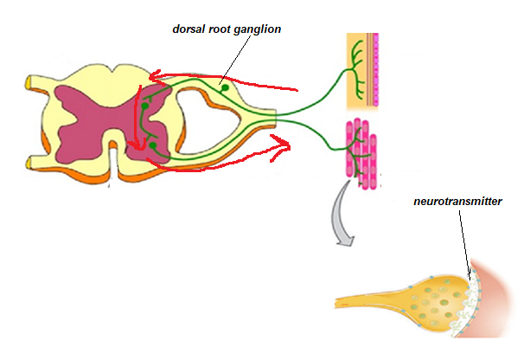

1. What process is shown in the diagram above? (1 mark)  
     
   A reflex Arc
2. Draw arrows on the diagram to indicate the direction in which impulses would flow through this system:

(1 marks)

1. Clearly label the dorsal root with ganglion and where the neurotransmitter would be located on the diagram above. (2 marks)
2. To make it easier to describe the various functions of the peripheral nervous system, it has been classified into divisions and subdivisions.

Complete the following table to classify and describe the neural pathway shown in the diagram above.

(7 marks)

|  |  |  |  |  |
| --- | --- | --- | --- | --- |
| Division(s) | Reason for choosing division(s) | Subdivision(s) | Reason for choosing subdivision(s) | Name of neurotransmitter(s) released |
| Sensory (1) and Motor (1) divisions of the PNS | Sensory neuron takes information from receptor to CNS (1)  Motor neuron takes information from CNS to effector (1) | Somatic Motor subdivision (1) | Motor neuron is stimulating skeletal muscle (1) | Ach (1) |

**Question 37:**



1. What process is shown in the diagram above? (1 mark)  
     
   A reflex Arc
2. Draw arrows on the diagram to indicate the direction in which impulses would flow through this system:

(1 marks)

1. Clearly label the dorsal root with ganglion and where the neurotransmitter would be located on the diagram above. (2 marks)
2. To make it easier to describe the various functions of the peripheral nervous system, it has been classified into divisions and subdivisions.

Complete the following table to classify and describe the neural pathway shown in the diagram above.

(7 marks)

|  |  |  |  |  |
| --- | --- | --- | --- | --- |
| Division(s) | Reason for choosing division(s) | Subdivision(s) | Reason for choosing subdivision(s) | Name of neurotransmitter(s) released |
| Sensory (1) and Motor (1) divisions of the PNS | Sensory neuron takes information from receptor to CNS (1)  Motor neuron takes information from CNS to effector (1) | Somatic Motor subdivision (1) | Motor neuron is stimulating skeletal muscle (1) | Ach (1) |